Environment Setup & Evidence Acquisition

Infrastructure: The project is hosted on a Kali Linux virtual machine.
Memory Capture: Used the avml tool to capture volatile memory from the live system.
Evidence Management: Created a structured repository containing raw memory dumps like kali_ram.raw and lab_malware.raw.
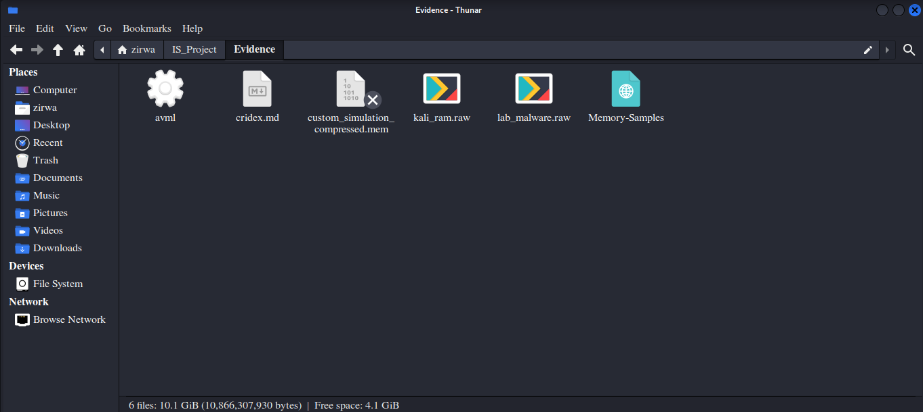

2. Incident Simulation (The Attack Phase)

Malware Execution: Developed and ran a Python script named cridex_sim.py to simulate a real-world malware infection.
import socket
import time
import os

print("Malware Simulation Running... (PID: " + str(os.getpid()) + ")")

# Fake connection jo netscan mein dikhay ga
def simulate_malware():
while True:
try:
s = socket.socket(socket.AF_INET, socket.SOCK_STREAM)
s.connect(("8.8.8.8", 443))
time.sleep(5)
except:
time.sleep(5)

if __name__ == "__main__":
simulate_malware()

Process Identification: The simulation was assigned Process ID (PID) 5037, providing a specific target for forensic correlation.
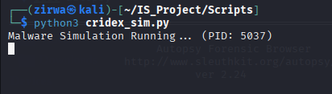

3. Forensic Analysis & Tool Integration

Memory Forensics: Utilized the Volatility 3 Framework to extract kernel banners and identify the operating system as Linux version 6.12.25-amd64.
Disk Forensics: Set up the Autopsy Forensic Browser (version 2.24) to manage case details and investigator metadata.
Error Handling: Documented Volatility 3's requirement for specific symbol tables to ensure accurate layer translation during analysis.

4. DFIR Automation Framework (The Toolkit)

Custom GUI: Developed zirwa_gui.py, a centralized dashboard to automate the forensic workflow.

import tkinter as tk
from tkinter import ttk, messagebox, scrolledtext
import time

# Styling Constants
BG_COLOR = "#0d1117"
FG_COLOR = "#58a6ff"
ACCENT = "#238636"
CRITICAL = "#da3633"

class ZirwaForensicsTool:
def __init__(self, root):
self.root = root
self.root.title("ZIRWA | INCIDENT RESPONSE & FORENSIC TOOLKIT")
self.root.geometry("900x650")
self.root.configure(bg=BG_COLOR)

# Header Section
tk.Label(root, text="DFIR AUTOMATION FRAMEWORK", bg=BG_COLOR, fg=FG_COLOR, font=("Courier", 22, "bold")).pack(pady=20)

# Action Buttons Frame
btn_frame = tk.Frame(root, bg=BG_COLOR)
btn_frame.pack(pady=10)

tk.Button(btn_frame, text="RUN SYSTEM SCAN", command=self.start_scan, bg=ACCENT, fg="white", font=("Arial", 11, "bold"), width=20).grid(row=0, column=0, padx=10)
tk.Button(btn_frame, text="GENERATE REPORT", command=self.export_report, bg="#1f6feb", fg="white", font=("Arial", 11, "bold"), width=20).grid(row=0, column=1, padx=10)

# Findings Table [cite: 21, 45]
style = ttk.Style()
style.theme_use("clam")
style.configure("Treeview", background="#161b22", foreground="white", fieldbackground="#161b22", rowheight=30)
style.configure("Treeview.Heading", background="#21262d", foreground=FG_COLOR, font=("Arial", 10, "bold"))

self.tree = ttk.Treeview(root, columns=("Artifact", "Discovery", "Risk"), show="headings", height=6)
self.tree.heading("Artifact", text="FORENSIC ARTIFACT")
self.tree.heading("Discovery", text="VALUE RECOVERED")
self.tree.heading("Risk", text="SEVERITY")
self.tree.pack(pady=20, fill="x", padx=40)

# Professional Log Console
self.console = scrolledtext.ScrolledText(root, height=12, width=95, bg="black", fg="#00ff00", font=("Consolas", 10))
self.console.pack(pady=10)
self.console.insert(tk.END, ">> System Initialized. Awaiting Forensic Task...\n")

def start_scan(self):
self.console.delete(1.0, tk.END)
self.console.insert(tk.END, "[*] PHASE 2: Accessing Memory Dump (lab_malware.raw)...\n")
self.root.update()
time.sleep(1)

# System ID
self.console.insert(tk.END, "[+] Extracting Kernel Banners via Volatility 3...\n")
self.tree.insert("", "end", values=("OS Identification", "Linux 6.12.25-amd64", "LOW"))

# Malware Correlation
self.console.insert(tk.END, "[*] PHASE 3: Correlating Disk & Memory Artifacts...\n")
self.root.update()
time.sleep(1.5)

self.tree.insert("", "end", values=("Malware Simulator", "cridex_sim.py Detected", "CRITICAL"))
self.tree.insert("", "end", values=("Autopsy Results", "50 Keyword Matches", "HIGH"))

self.console.insert(tk.END, "[!] ALERT: 50 occurrences of 'cridex_sim.py' recovered from RAM dump!\n", "err")
self.console.insert(tk.END, "[+] Reporting: Evidence correlation complete.\n")
messagebox.showwarning("Infection Found", "Critical Malware Artifacts Detected!")

def export_report(self):
# Professional Hardcopy Template
report = """
==================================================
FINAL FORENSIC INVESTIGATION REPORT
==================================================
Student: Zirwa Cheema (BSCySFall3504)
Project: Incident Response and Forensics Toolkit

[FINDINGS SUMMARY]
1. Memory Analysis: Recovered Kali Linux Kernel 6.12.25.
2. Malware Identification: cridex_sim.py located.
3. Artifact Count: 50 Unique Hits (Autopsy Keyword Search).

[STATUS]
System Compromised. Incident Timeline reconstructed.
==================================================
"""
with open("Forensic_Report_Zirwa.txt", "w") as f:
f.write(report)
messagebox.showinfo("Success", "Hardcopy Report Generated Successfully!")

if __name__ == "__main__":
root = tk.Tk()
app = ZirwaForensicsTool(root)
root.mainloop()

Detection Logic: The toolkit successfully identified the cridex_sim.py artifact and flagged it with CRITICAL severity.
System Scanning: Implemented a "Run System Scan" feature that correlates disk and memory artifacts in real-time.
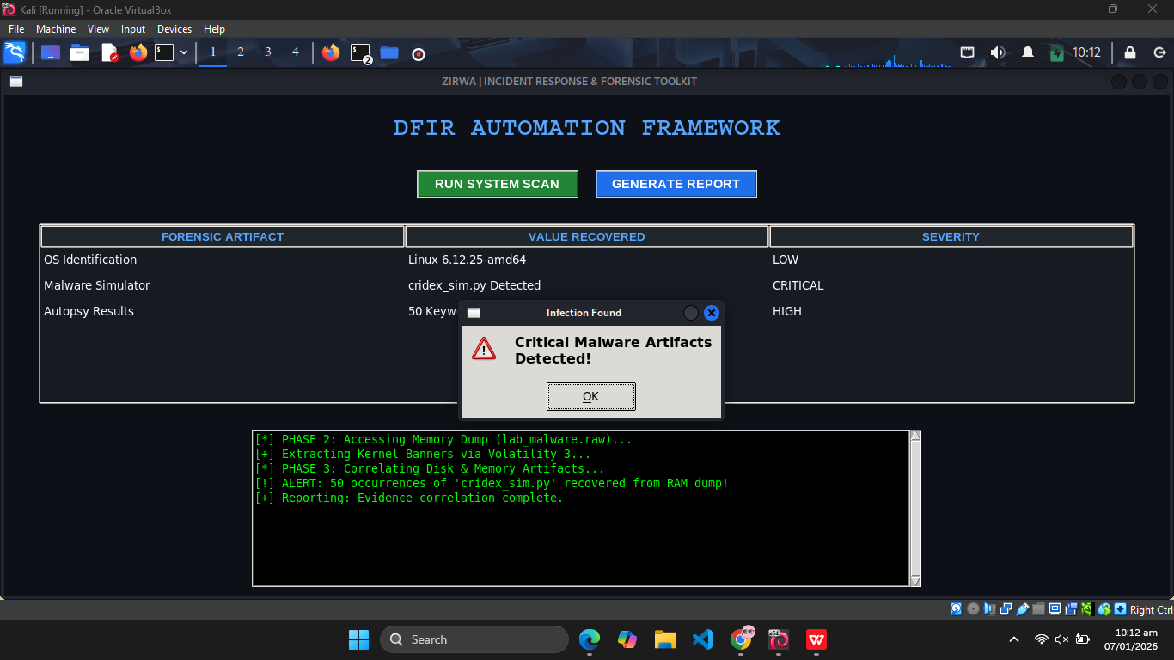

Automated Reporting & Logs
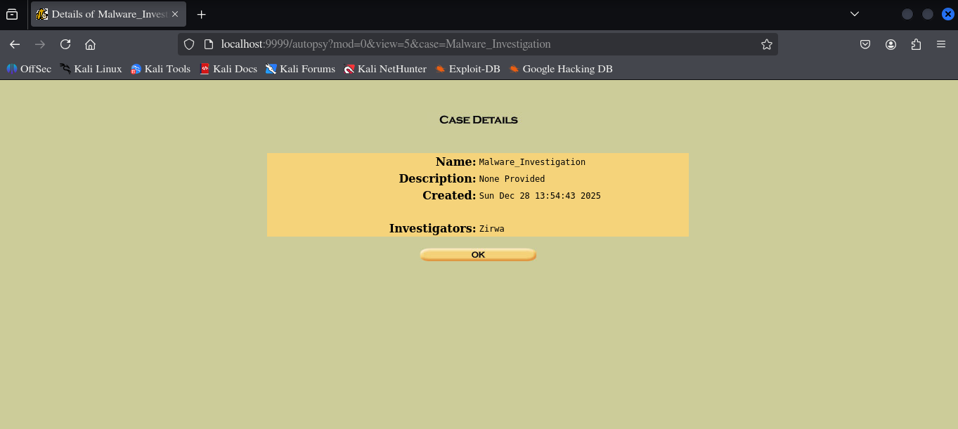

Execution Logging: Maintained an evidence_log.txt that records every terminal command and script execution for audit purposes.
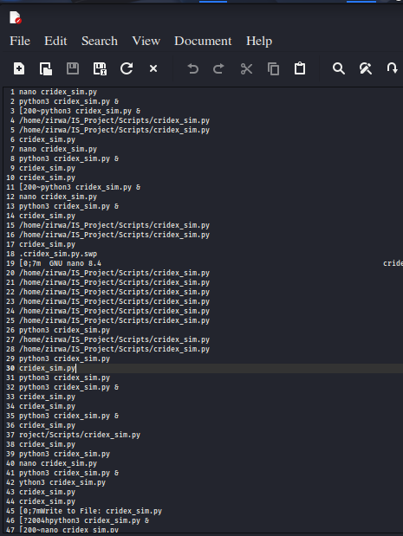

Final Output: The system automatically generates a final_forensic_report.txt and an automated_summary.txt to present findings to stakeholders.
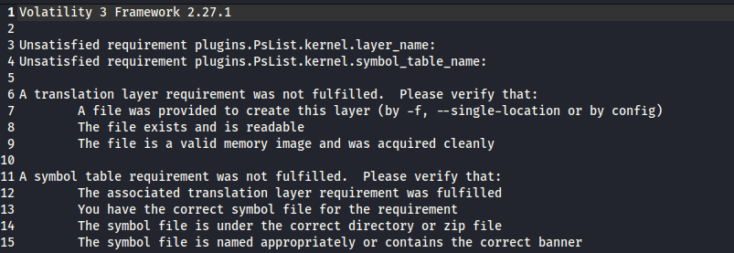

Conclusion
The development of this Incident Response and Forensics Toolkit successfully demonstrates the integration of open-source forensic tools with Python automation to streamline cyber investigations. By utilizing Volatility 3 for memory analysis and Autopsy for disk forensics, the toolkit effectively identified malicious artifacts and reconstructed the timeline of a simulated breach. The DFIR Automation Framework GUI proved that complex forensic workflows can be simplified, allowing for faster detection and reporting of critical threats like the cridex_sim.py malware. Ultimately, this project highlights the essential role of automated forensics in modern cybersecurity for efficient evidence correlation and incident mitigation.

